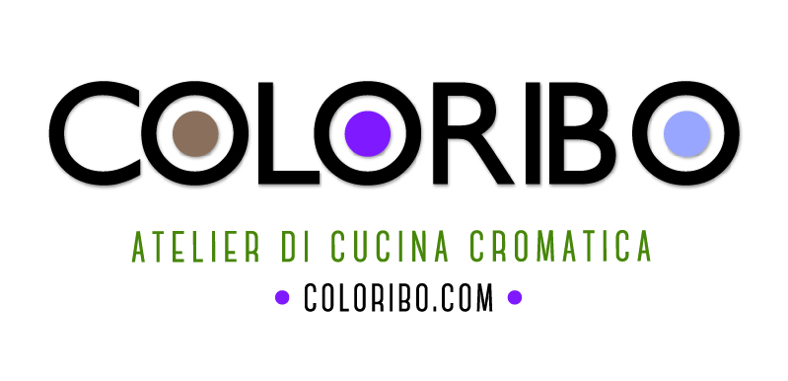

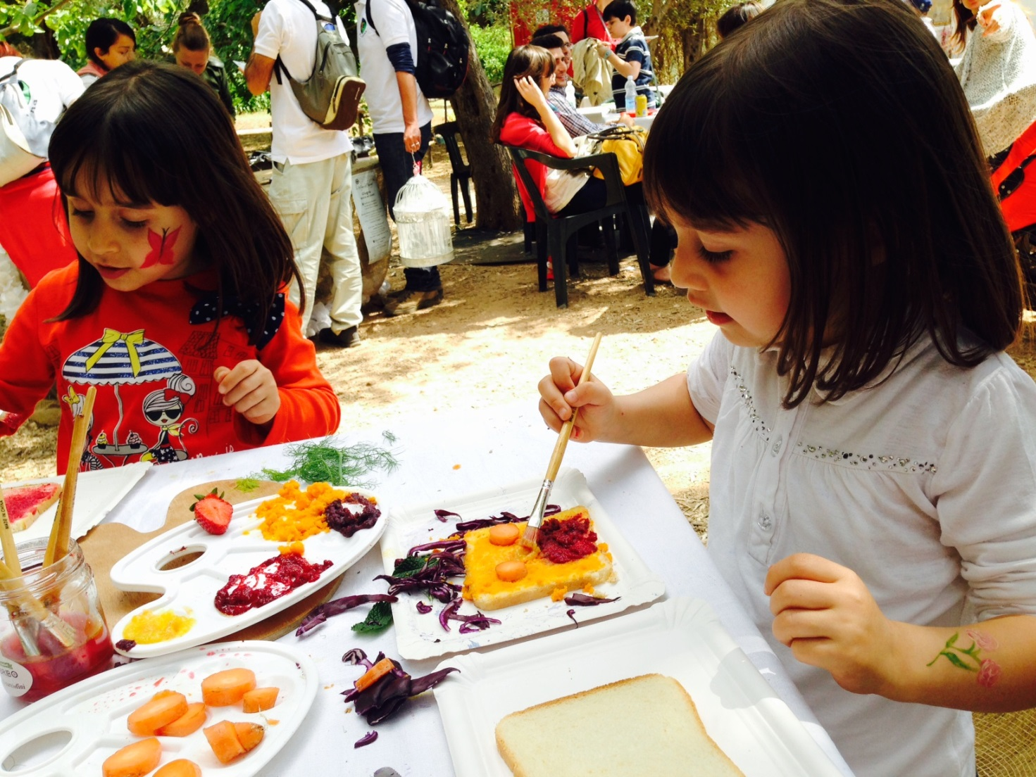
Merenda colorata per i bambini.
Healthy and colorful snack for children by Bice Perrini (artist and personal-chef).
www.coloribo.com/en
Per info Bice Perrini cell.+39-3923281905(Bari-Italy)

